Description of the Presence and Role in the Local Immunopathogenesis of Tertiary Lymphoid Structures in Non-Obese Diabetic (NOD) Mice at Different Stages of the Disease.
^{1,2} Escamilla-Sánchez A., ³González-Mariscal I., ⁴Pacini A., ⁴Villar S., ^{1,5}Sánchez-Varo R., ^{1,5}López-Villodres J.A., ^{1,5}García-Díaz B., ^{1,5}Mercado-Sáenz S and ¹Bermúdez D.
¹ Departamento de Fisiología Humana, Histología Humana, Anatomía Patológica y Educación Física y Deportiva, Facultad de Medicina, Universidad de Málaga, Málaga, Spain.
² Grupo Traslacional de Inmunoterapia del Cáncer, IBIMA Plataforma Bionand, Málaga, Spain.
³ Institut National de la Santé et de la Recherche Médicale (INSERM), Lille, France.
⁴ Instituto de Inmunología Clínica y Experimental de Rosario IDICER-CONICET, Argentina. Facultad de Ciencias Médicas, UNR, Argentina
⁵ IBIMA Plataforma Bionand, Málaga, Spain.

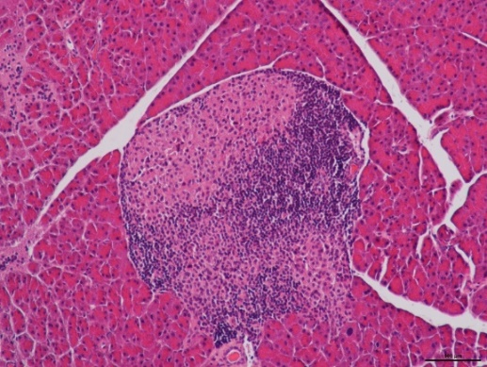
Introduction: Tertiary lymphoid structures (TLS) comprise aggregates of immune cells, notably B lymphocytes, within a network of fibroblasts interacting with T lymphocyte areas. These structures facilitate direct communication with neoantigens, enabling dendritic cells to interact with activate T lymphocytes. Positioned precisely where pathology takes development, TLS hold significant importance in disease pathogenesis. In neoplastic diseases, a positive correlation with subsequent immunotherapy response has been observed. Conversely, in autoimmune diseases such as Type I diabetes mellitus, the stimulation and formation of these structures lead to increased production of auto-antibodies and subsequent tissue damage. Despite the fact that there are autoimmune pathologies in which these structures have been extensively described, in the case of Type I diabetes mellitus, there are still many unanswered questions.The non-obese diabetic (NOD) mouse model is extensively used to study Type I diabetes mellitus. In these mice, the disease develops due to leukocyte infiltration into pancreatic islets, resulting in insulinitis, thus allowing the study of pathogenesis and its extrapolation to human conditions.
Materials and Methods: Thirty female NOD/ShiLtJ mice aged 4-5 weeks were housed in groups of four, fed standard chow, and provided water ad libitum.Three groups (G) of 10 mice each were formed: G1 euthanized at 5 weeks, G2 at 11 weeks, and G3 at 20 weeks. Pancreatic samples were collected during necropsies and fixed in 4% paraformaldehyde for histochemical tests such as Masson's trichrome, immunohistochemistry (including TUNEL), and multispectral immunofluorescence to establish a panel for characterizing and describing the development and presence of TLS. Different cellular localization markers have been employed, such as anti-CD20, anti-CD19, anti-CD138, to phenotype B lymphocytes, along with a panel of biomarkers for tertiary lymphoid follicles consisting of anti-CXCR5, anti-CD21, and anti-PNAd. Therefore, a histopathological study was conducted using H&E staining to determine, through a semi-quantitative analysis, the severity of inflammatory infiltration at different stages.
Figure 1. Moderate to severe inflammatory infiltration in the islet of Langerhans of NOD mouse at 11 weeks of age.
Results: Preliminary analyses indicate that the presence and degree of TLS maturation exhibited a varying trend throughout pathogenesis. Differences were also observed in fibrosis deposits within Langerhans islets, as well as TUNEL technique positivity.
Conclusions: Understanding the presence and formation of tertiary lymphoid structures in the pancreas of NOD mice and relating it to local immunopathogenesis at different stages of the disease could be one of the exacerbating factors of the pathology, as well as disease maintainers.

